1.PUTTY

* Download link for putty
* <https://www.chiark.greenend.org.uk/~sgtatham/putty/latest.html>
* PuTTY Portable is a telnet and SSH client so you can connect to remote computers and servers

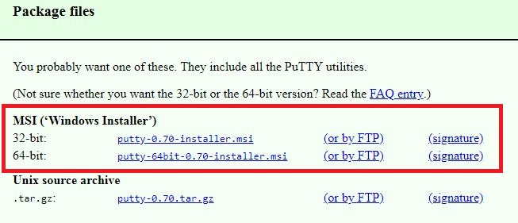

**2.**PUTTYGEN

* Download link for puttygen
* <https://www.chiark.greenend.org.uk/~sgtatham/putty/latest.html>
* Puttygen is used for generate the .ppk file

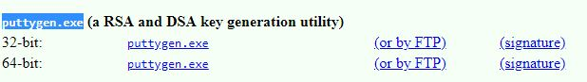

3.How to Create keypair for instance

* Here i am create the keypairname that is .pem key (mykey.pem)

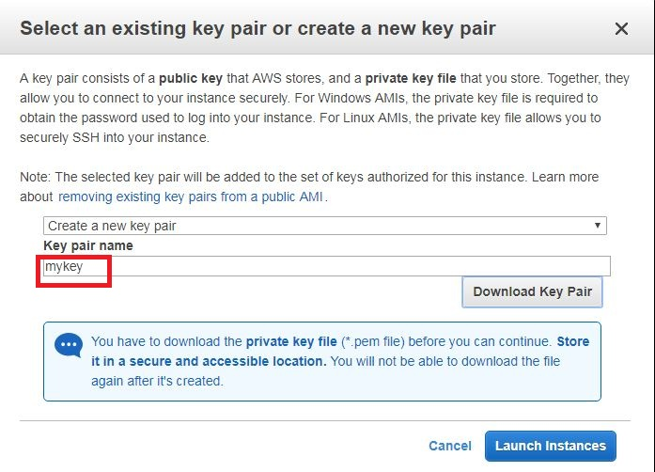

4.How to connect the instance through Putty

* keypair is create sucessfully
* connect instance click on connect

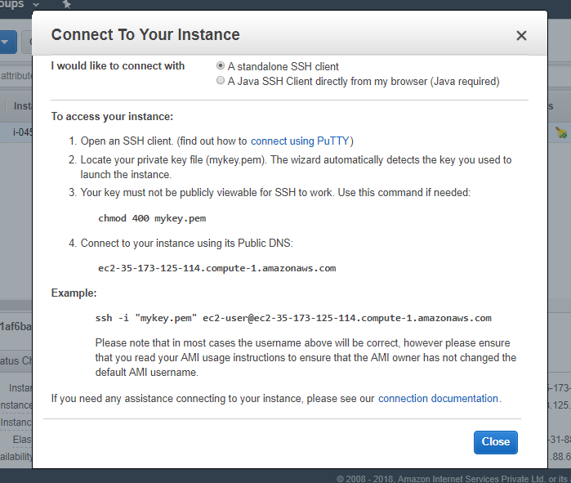

* here i am not generate any private key that is .ppk file
* I am trying to connect .pem key that is public key so instance is not conneted see below

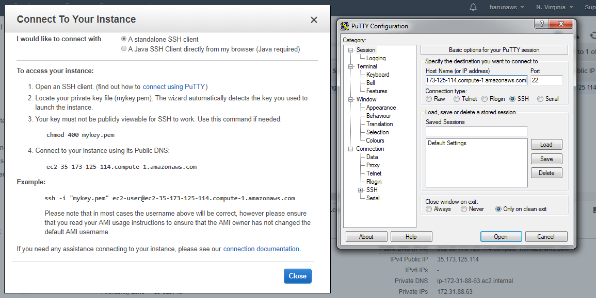

* Here i am selected mykey.pem key

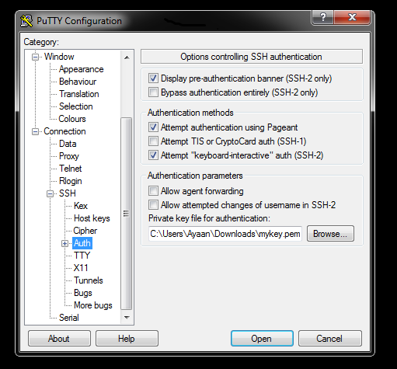

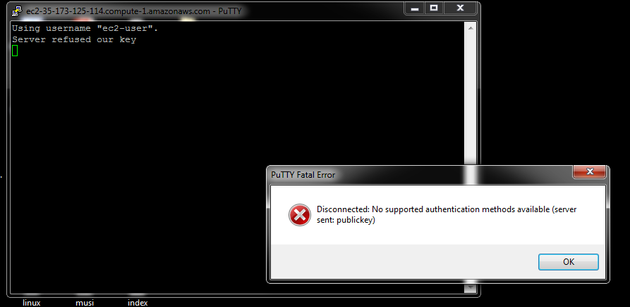

* authentication problem
* Now I am creating .ppk that is private key

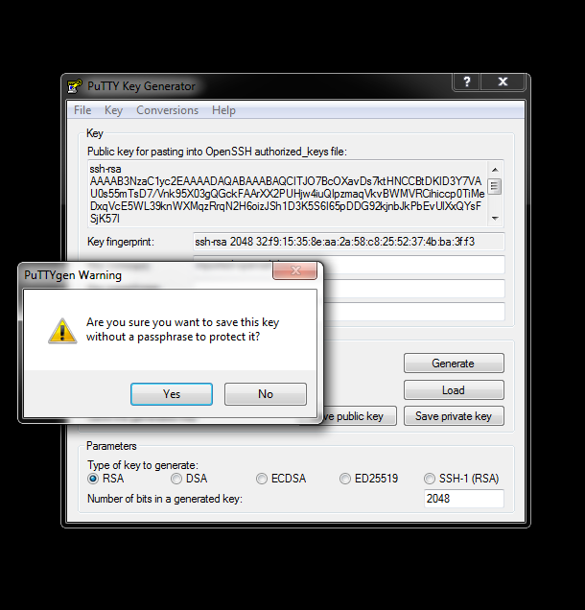

* Sucess fully created private .ppk file
* Now i am trying to connecting instance



